Week 2 summary
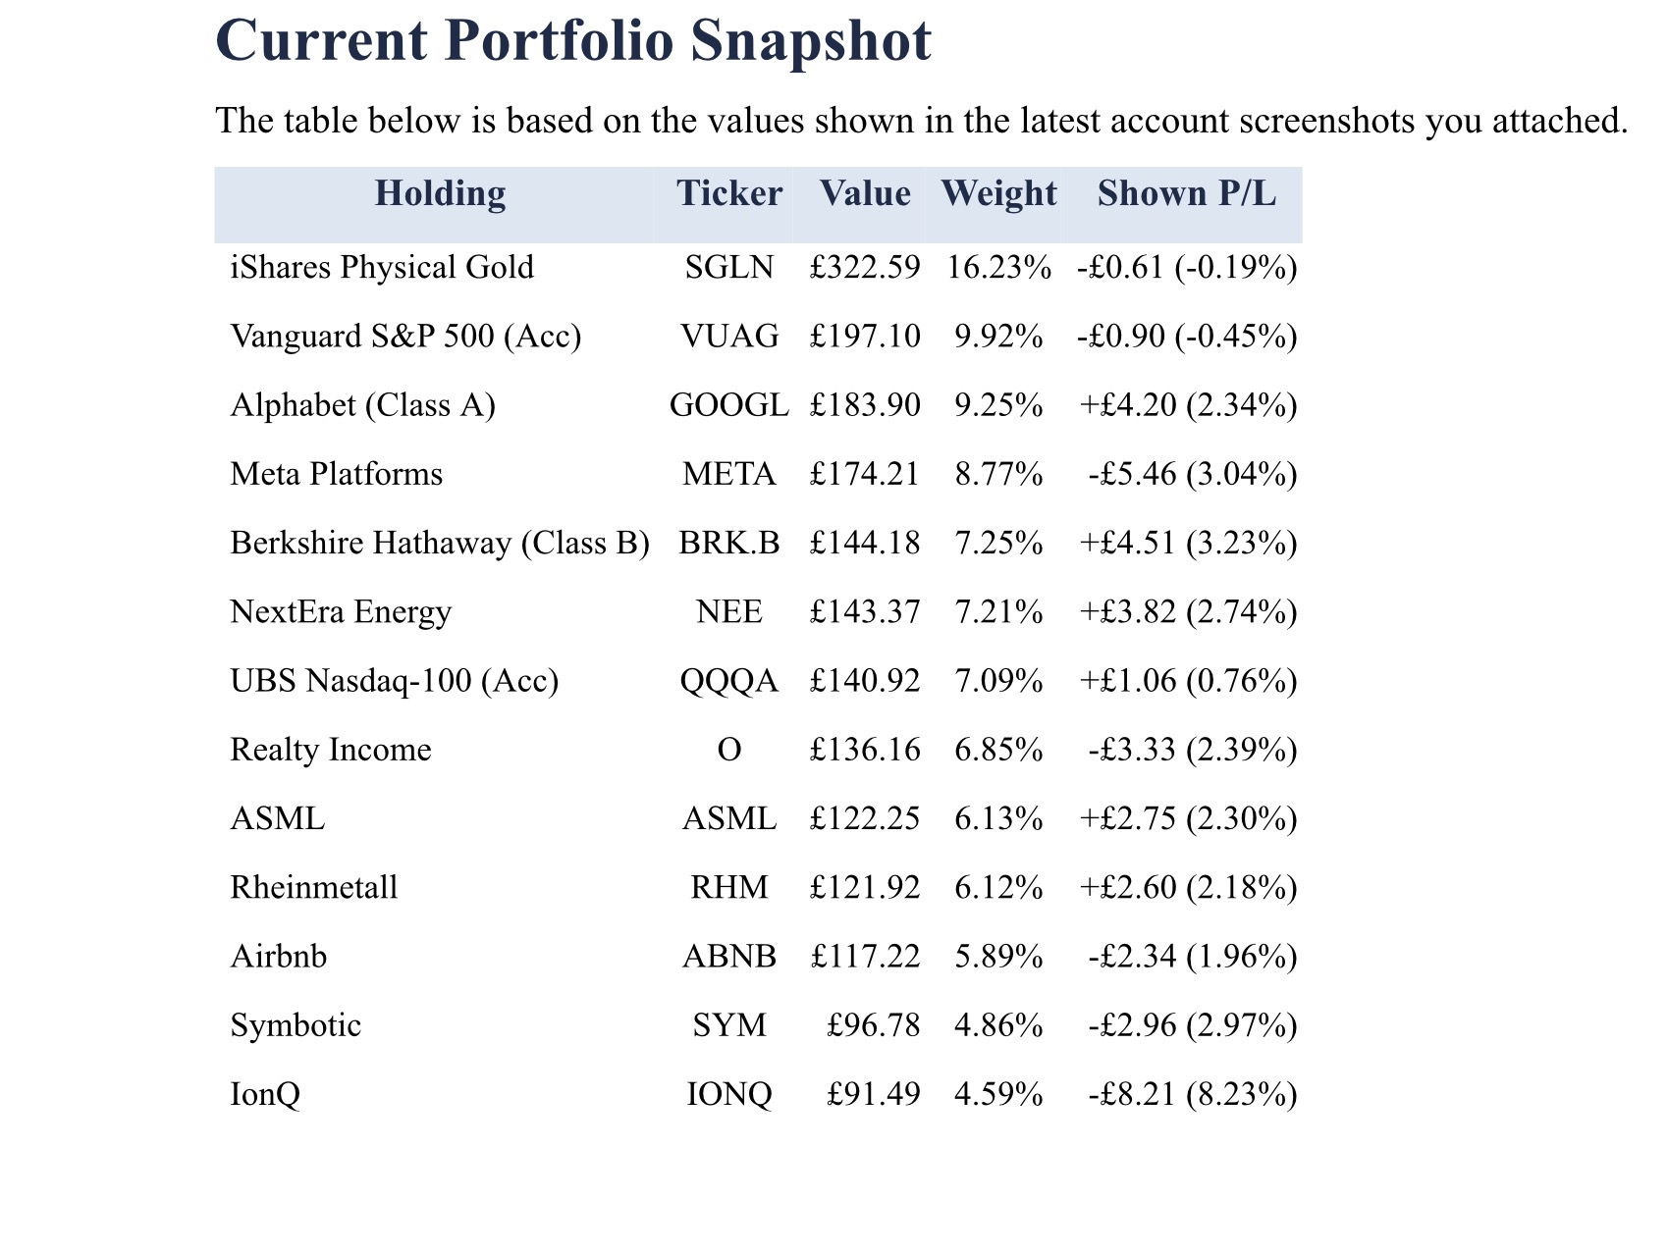

This second week continues to show that the portfolio is behaving broadly in line with what I wanted when I first built it. The account still feels balanced between quality growth, broad market exposure, defensive holdings and a smaller speculative sleeve. The speculative names remain the main source of volatility, but they are not large enough to dominate the whole portfolio, which is an important sign that the position sizing is doing its job.

The strongest overall takeaway from Week 2 is that the portfolio still has a solid core. Alphabet, Meta and ASML remain supported by the wider AI and infrastructure backdrop, while Berkshire Hathaway, the ETFs and gold continue to add structure and stability. That matters because it means the account is not relying on one single theme or one single high-beta trade to work. Even where there is short-term weakness, the broader portfolio construction is helping keep the account under control.

In the more defensive and stabilising part of the account, gold still looks useful as a hedge, Berkshire Hathaway still provides quality ballast, and the ETF sleeve continues to do what it should by giving broad market exposure without forcing me to be right on every single stock. Realty Income and NextEra also help the balance of the portfolio, even though they are not the types of names that tend to generate the most excitement from week to week. Their role is to improve resilience rather than chase the biggest move.

The more mixed part of the portfolio remains the speculative sleeve. Symbotic and IonQ are still the areas most likely to move sharply over short periods, and that was reflected again this week. However, the main point is not simply that they were weaker on price. The more important point is that both names are still giving enough operational progress to justify monitoring them through execution rather than reacting emotionally to every swing. IonQ remains the most speculative position in the portfolio, so that is the one I need to watch most carefully from a risk-control perspective.

Europe was also a useful reminder this week that there is a difference between company quality and market expectations. Rheinmetall still appears to be backed by a strong long-term defence case, but the latest reaction shows that when a stock has already run hard, even good updates can be treated as a disappointment if the market was expecting something even stronger. ASML, by contrast, still looks important as one of the cleaner long-term ways to own the semiconductor infrastructure side of the AI build-out.

My overall conclusion for Week 2 is that the portfolio still looks disciplined rather than random. The core holdings are still doing most of the structural work, the defensive sleeve is still useful, and the speculative positions are still small enough to stay manageable. The main job from here is to keep reviewing each name against the original reason for owning it, rather than overreacting to short-term price movement. If that discipline stays in place, then the portfolio still feels on the right track.

What I Should Follow Into Week 3
• Keep an eye on AI capex sentiment around Alphabet, Meta and ASML, because these positions are central to the portfolio's quality-growth core.
• Track whether Rheinmetall's weakness is only an expectations reset or the start of a broader reassessment of defence names after a strong run.
• Monitor Symbotic and especially IonQ through execution updates rather than price alone.
• Watch rates and financing sentiment for NextEra and Realty Income.
• Continue treating gold as a portfolio hedge rather than a short-term trading position.
• Make sure no single position drifts into becoming too dominant relative to the rest of the account

